

**Master Of Science in Finance Department**

**School of Management**

**University at Buffalo**

**MSF. Semester-I**

**2022-23**

**MGF685LECF1F - International Finance Management**

**Case Studies: China to Float or Not Float(A)**

**China to Float or Not Float(c)**

**Under the Guidance of**

**Prof.Veljko Fotak**

**Submitted by:**

**Harsh Chodvadia**

**NitinVankayalapati**

**Tanisha Shetty**

**Varshil Shah**

Q1) Summarize and evaluate the arguments presented in the (A) case for and against the revaluation of the renminbi. Provide your own assessment: should the RMB be revalued in 2005? Should it be free floating or managed, in 2005?

China started to peg its currency against USD since 1994, its initial peg value is 8.28 Yuan to USD.Under pressure, China revalued its currency in July 2005. The value of Chinese Renminbi appreciated by 2.1% making the exchange rate 8.11 Yuan for one USD. It is on this day China announced that it will no longer peg its currency with US dollar but will have RMB’s exchange rate derived from an undisclosed basket of currencies. This is one of the major steps taken by China to “manage” RMB.

If China did not revalue its currency and would have let RMB peg USD, the appreciating dollar would have led to an appreciation in RMB. This could have been one of the reasons why China decided on managing its currency against a basket of currencies. China would not want its currency to appreciate as it would make its exports costly alternatively, if the RMB was undervalued, it would make the import of Chinese goods into US cheaper, further strengthening the Chinese RMB and GDP.

If RMB appreciates, it would reduce exports and create social stability issues in China as the Manufacturing or assembling MNCs in China would withdraw and would be interested in new low-cost markets like India and other South Asian countries, which in turn will help other economies grow. Until 2000 China was much interested in growing country’s GDP through local consumption but from early 2000’s China started exporting good from diverse industries further making their GDP grow through exports. China is now open for world trade. With China’s membership in WTO in 2001, the export industry in China became further strong due to tax exemptions on import of goods from WTO member nations. We can see drastic increase in Chinese exports to US from 2001 to 2004 in Exhibit 7. We second with argument made by US Federal Reserve Chairman Alan Greenspan but if the RMB were to rise it would mean US would not be over dependent on China for its import needs and would be less vulnerable to changing socialistic ideas of China or any political risk that China poses.

Chinese banking system is controlled entirely by the government of China, who would coerce their socialistic ideas into the system. From the data provided in Exhibit 6, we see that Chinese imports are equally high as their exports, meaning that China must import a lot of raw materials from other countries. Most of the work done in China is assembly or processing of raw materials which would also be done in the country of import (US in this case) with proper availability of technology and labour.

RMB should be revalued/floated in 2005 as the RMB being undervalued would affect the other world economies and would give undue advantage to China. But this could also cause ripple effect, as govt controls the banking system in China and has a lot of USD reserves or has restrictions on selling USD on its banks(as they sell RMB and buy USD to maintain the supply of RMB in the market and to maintain stability in their exchange rate), the Chinese govt uses these reserves or any inflow of USD to purchase the US treasury bonds, if RMB is revalued/floated and if RMB appreciates, demand for Chinese goods would come down and this would mean that China would not be able to purchase the US treasuries (Note that China is one of the 5 top holder of US debt) which in turn would affect the US at times of deficit.

China should concentrate on its domestic consumption to increase its GDP rather than managing the currency to increase the exports. Which as per People’s Bank of China Governor Zhou Xiaochaun is what China is working on.

Floating RMB would also mean that some of the US manufacturing jobs might returns to US which would help curb the unemployment rate in the states.

Some of the Firms that are dependent on China for assembling or processing of their products such as Walmart the cost of their products might go up due to floating/revalued RMB as it would mean they have to pay higher rates for the services rendered by Chinese manufacturers/service providers.

As Chinese economy is mostly dependent on the export of goods and services, it would be better for China to slowly start appreciating its currency by buying RMB as China would be most hurt if US (Major importer of Chinese goods) finds other major supplier of cheaper goods and decides on shifting its imports from China to the other major supplier. This would mean that the demand for RMB in global market would be lesser than its supply, as companies would not want to invest in China due to shift in the US imports to an entire new country, causing the RMB to fall drastically and China would not be able to buy the RMB back as China’s vast reserves would not be sufficient to manage the falling knife as quoted by former IMF chief Economist Rogoff.

Appreciation of RMB would also mean that the investor would not be willing to invest in China. Gradually floating the RMB is the suggestion as floating RMB right away might impact the economies of all the countries that import goods from China as the imported goods will be costly which would further increase the inflation in the system should be managed to an extent as floating it might cause economic distress.

Q2) What are the implications of changes in China’s exchange rate policy on companies located in China, and foreign companies doing business in China?

Exports from China have been affected since the appreciation in currency exchange rate which would cause some stir in its economic growth. A spokesperson from People’s Bank of China shared with the official Xinhua News Agency, “In the short term, reform of the exchange rate mechanism will have some impact on economic growth and employment.

The main reason for going ahead with the reforms in Renminbi Exchange Rate Mechanism is to ease out the external trade imbalances. Post this reform, as per Chinese Customs data, China’s trade surplus reached $40 million in the first six months while at the same time the exports grew 33% over the period last year.

As per economist Zhang Shuguang, 2 percent change is a very limited change and that it won't have a very major effect on businesses. Major impact would be on labour intensive processing businesses with low profit margins and not the whole sector.

There are a few businesses being affected comparatively more than others. For example, Steel is highly exported from China and hence a change of 2% would hardly make any difference to businesses dealing with this product. At the same time an individual named Ruan Xiaoming, manufacturer of sewing machines in eastern China with a small company named Gemsy Holding Group had to take a big blow as a result of this reform. The profit margin being reduced by 2% is a substantial loss for a small company like Gemsy Holding Group.

Exporters in China believe that large entities would have to face losses but it would be the same for their competitors too. Some smaller entities would cease to exist as this exchange rate reform would affect them miserably. Nanheng Furniture Production is one of the large furniture companies dealing with furniture in southern China. Mr. Liu Peisheng, the deputy manager of this company believes that the cost of China is too cheap for their customers to shift to other Asian countries.

Q)3 What are the specific ways in which Esquel might be impacted by the recent exchange rate policy changes and any future changes that you envisage? How can Esquel mitigate any threats and take advantage of any opportunities presented by these changes?

As in the case study, the Renminbi was revalued by 2.1%, which will inevitably reduce their overall profit margin as 60% of their exports were to the US, 15% to Europe, and 15% to Japan. It's also possible that the Esquel's importers will find the company's garments to be too pricey to purchase and will start seeking for alternatives. Analysts anticipated that the renminbi is about 35% undervalued, thus there is a very strong likelihood that the products of esquel will be overpriced. The corporation may need to fire some workers in China as a result of the devaluation in order to cut expenses since the profit margin might decrease.

Additionally, it would be challenging to take any action given the future unpredictability of the dollar-yuan exchange rate because any mistake in terms of raising output or lowering employment might have a negative impact on the company's balance sheet. Even currency hedging would not be effective because there was no direct conversion to local currency, and utilizing NDF futures to hedge currencies looked to be ineffective because the premiums were 5%, meaning that any profits would have to be more than 5% to be effective.

One choice is to engage an interest rate swap using the RMB as the notional currency, where the corporation would exchange a fixed interest rate for a variable interest rate under the presumption that the rmb would appreciate. In the next ten years, the corporation can aim to boost its revenue from 5% to 15-20% by starting to increase its sales in China. It should concentrate on increasing PYE. It should move production out of high-wage coastal regions and into non-coastal areas.

As China lends and donates money to low-income nations for infrastructure development, it may exert control and oversight over the manufacturing facilities in these nations, giving it the authority and influence to lower production costs. Because of the cheap wages, it is possible to increase manufacturing efficiency in other nations, and that day may not be too far off. To achieve this, they only need to build on the infrastructure and supply chain improvements provided by the Chinese government. This may also result in the firing of certain Chinese workers and the employment of individuals from underdeveloped nations. Since the company is entering more into service-based business, it can focus more on design and luxury garments along with hard core manufacturing so as to increase their revenue per product.

Q4) How has China actually acted in the following years (2005-2021) from the standpoint of its visible policy towards the RMB/USD exchange rate? (Note: you need external data for this, not included in the case). In light of this recent history, do you believe current calls (in 2022) for a change in valuation of the renminbi are justified (is the RMB overvalued, or undervalued, in September, 2022)?

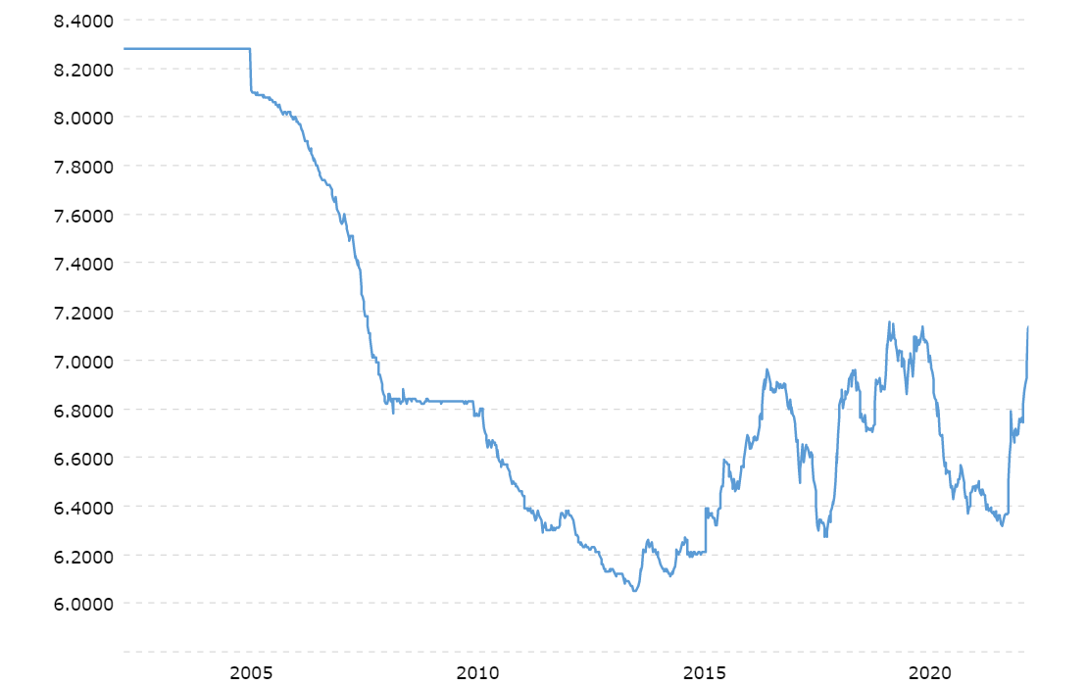

USD/RMB (Fig1)

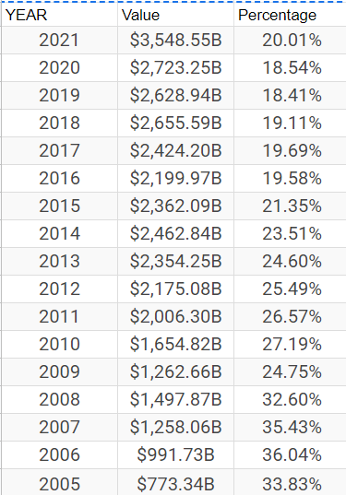

Export Table of China (Fig2)

The Chinese government revised its monetary and fiscal policy on July 21, 2005. Furthermore, it announced that the US dollar ( $ price) will be altered from 8.28 yuan to 8.11 yuan, a 2.1% rise, and that the RMB exchange rate would become changeable, depending upon Economic concept -market supply and demand with reference to exchange rate swings of currencies in a basket. In Contrast to this Chinese Government allowed RMB to move daily against the basket by up to 0.3%. China halted its currency appreciation policy around mid-July 2008 mostly as a result of decreased worldwide demand for Chinese products as a result of the global financial crisis's impacts. Chinese exports declined 15.9% year on year in 2009. Because of the immediate consequences of the global economic downturn, the Chinese government estimated that thousands of export-oriented enterprises were closed. In response, the Chinese government stepped in to stop the RMB from continuing to appreciate against the dollar. Through mid-June 2010, the RMB/dollar exchange rate remained mostly unchanged at 6.83.After, Financial crises from the data in the table the export increase steadily from 24.75% to 26.57% in 2011.Then die to instability in yuan also it appreciated with compare to USD.Then it decrease to 18.54% in 2020

For Currency is overvalued or undervalued can be tell by Purchase power parity(PPP).The purchase power parity means the rates of currency conversion that try to equalise the purchasing power of different currencies, by eliminating the differences in price levels between countries. So for this case we have taken Big Mac index for comparing purchase power parity between China &USA. Basically, Big mac Index was created by Economist to measuring PPP between nations, using the price of a McDonald's Big Mac as the benchmark.

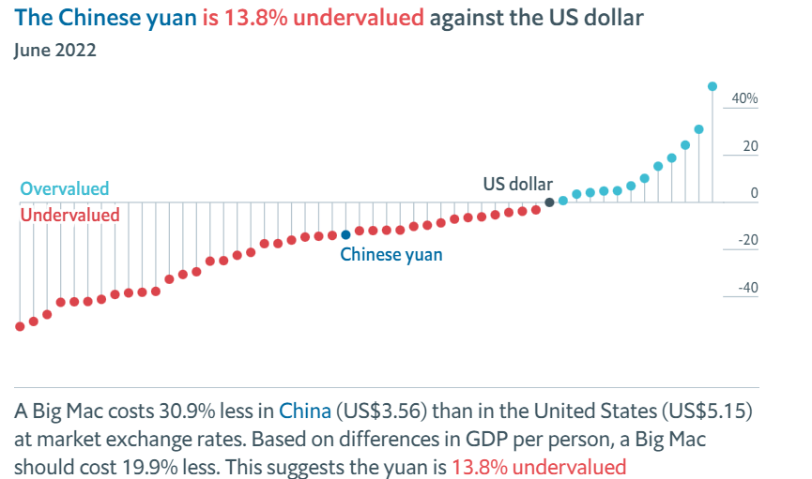

(FIG3)Big Mac Index

Q5. In April 2021, China announced the creation of a new digital currency, controlled by its central bank. Do you think this is a good idea? Why or why not? How does this compare to the situation of El Salvador and its adoption of Bitcoin? (note: you will need a bit of external research to get the necessary background information). What impact (if any) would this new digital currency have on Chinese export-oriented firms like Esquel?

I think digital currency it is a good idea because it is Highly Regularized & Stable, Can Replace all Privately Owned Cryptocurrencies and it is more transparent, Auditability & Funds Tracing also it is governed by the central bank they will have the idea where the people is using the money there are so many case where people have siphoned the money to the other country where China has no bilateral treaty .CBDC(Central Bank Digital Currency)are recognized by law and backed by the power of central bank which cannot go bankrupt. For example, if a commercial bank collapses the part of your savings could wiped out, but his wouldn’t be case for CBDC which could be as trusted as payment app yet also benefit from the blockchain technology. Also, the duplicate notes will not be there in market and no one can duplicate it and also Integrated into Formal Monetary Framework and opportunities for new age fintech will be open, The e-yuan could also be used to navigate international transactions around payment systems and networks that can be shut off to Chinese financial institutions serving U.S.-sanctioned entities. The digital currency will bolster domestic financial security. Using a digital currency when someone buys anything the numerical address of the transaction can be only seen by the government and the company of the where someone purchased.

First of all the bitcoin is not control by any government or any companies. It is influence by all the people living in the world. So, the El Salvador purchase the 200-bitcoin worth 10.3$ billion. The maximum number of bitcoins that can be issued—mined—is 21 million. So if we take the percentage of the bitcoin is with El Salvador is only 0.000001 percentage. Bitcoin is controlled by all Bitcoin users around the world. While developers are improving the software, they cannot force a change in the Bitcoin protocol because all users are free to choose what software and version they use.

Suppose, someone has more bitcoin than El Salvador if they dump the bitcoin at any point then the value of bitcoin will also decrease. For instances, someone has to purchase the car it is value is 1$ million in a bitcoin as of now.But,when he/she going to purchase the car suddenly the value of bitcoin crash due to some reason and now the value of the 80,000 $ only due to highly volatile nature it can’t be used as a currency. Bitcoins are illiquid and have shown high price volatility, and that the discounted cash value of a bitcoin is zero. Further, observes the currency lacks a central issuer, and that there is no financial or economic basis for its creation.

There are some reasons we believe that Bitcoin ups and Downs depend directly on the statements of the government of different countries and some influence people. This volatility creates the problem in the short term.

The greater danger of Bitcoin includes money laundering, terrorist and other illicit activity funding, the lack of a central issuer, which means there is no legal formal organization to guaranty in the event of a bankruptcy, and so on. Although it is impossible to forecast, many scholars and experts in this field believe that the future of cryptocurrencies is bright since it will remove trade barriers and middlemen, reduce transaction costs, and so enhance commerce and the economy. Nonetheless, we need note and gloomy voices in the academic sector, claiming that the high risk of volatility, hacking concerns, and a lack of institutional backstop make the future of cryptocurrencies not very hopeful.

.

This is true for small and medium-sized industries located in developing nations in Africa, Asian and Eastern Europe with expensive and outmoded banking systems. These smaller companies who buy and sell to China have high banking fees related to wire transfers, paperwork, currency fluctuations and exchange rates. The time it takes to receive and send money can occasionally last up to a week, which slows down business. China’s Digital currency will allow customers large and small access to a digital environment for global trade, making transacting with China as easy as shopping on E-Commerce Website.

Conclusion

Until July 21, 2005, the Chinese Renminbi was being pegged to USD at a fixed exchange rate of 8.28 Yuan per USD. Reforms of Chinese Renminbi Exchange Rate Mechanism in the year 2005 was a colossal change as the Renminbi started being pegged at a floating rate under a basket of currencies which resulted in Renminbi being appreciated by 2.1%.

China realized that the Chinese economy was lagging behind its peers in terms of economic growth and development. It began with the Maoist Vision of a Centrally planned economy failing to encourage the economic growth of the country. The Communist party when came into power majorly focused on the development of the Agricultural Sector, State Owned Enterprises, Banking Sector, International Trade and Foreign Investments. The Chinese economy was highly dependent on Agriculture but eventually a shift was noticed from it to the manufacturing sector.

Esquel Group is one of the largest manufacturers of textile products in China. Established in 1978, it underwent a major expansion from the year 1995. Esquel was an end-to-end entity that began from weaving cotton shirts to packing the final product for shipment. Its biggest clients were US and European retail brands.

As a result of political and market pressure, yuan was revalued by 2.1% thus breaking a decade long practice and shifted to manage floating exchange rate based on market supply and demand, with reference to a basket of currencies.

A large portion of Esquel’s revenue was earned by exporting goods which were invoiced in USD.  When the Chinese Renminbi appreciated, the exports were bound to face a fall. As an entity engaged in a very traditional business set up, they have indulged in many innovative and modern approaches in getting an upper hand over and above their competitors because hedging their financial risks was not a practical strategy to deal with future unpredictability

There are several reasons why Bitcoin is not an acceptable form of payment. The price of bitcoin has had little impact on the economy thus far. From the stability perspective, it is not very important. Also, there is no central issuer which means there is no legal formal organisation to guarantee in the event of bankruptcy. Assume, that when the federal government issues the $100 bill, it will still be worth $100 years from now. It will depend on inflation, but the essential issue is that if one bitcoin was valued at $100, it would likely decrease because of its extremely fluctuating and volatile character and lack of central government supervision.

**APPENDIX**

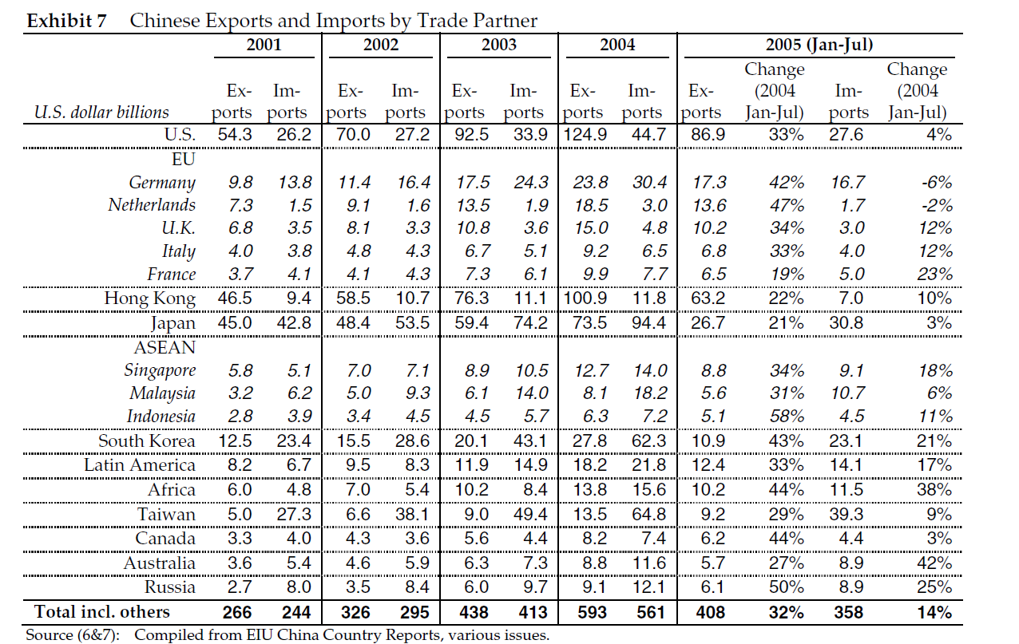

Reference :-

1. Fig(1)[US Dollar to Chinese Yuan Renminbi Exchange Rate Chart | Xe](https://www.xe.com/currencycharts/?from=USD&to=CNY)
2. Fig(2) <https://tradingeconomics.com/china>
3. Fig(3) [The Big Mac index | The Economist](https://www.economist.com/big-mac-index)